**Name: Harshavardhana K**

**USN: 1BM18CS035**

**Program Number : 4**

**Program Title : Motion detection sensor (PIR)**

**AIM: Basically to turn on the led whenever motion is detected by photo resistor.**

**Hardware Required:**

* **Arduino Board**
* **Led**
* **Photo resistor**

**Circuit Diagram:**

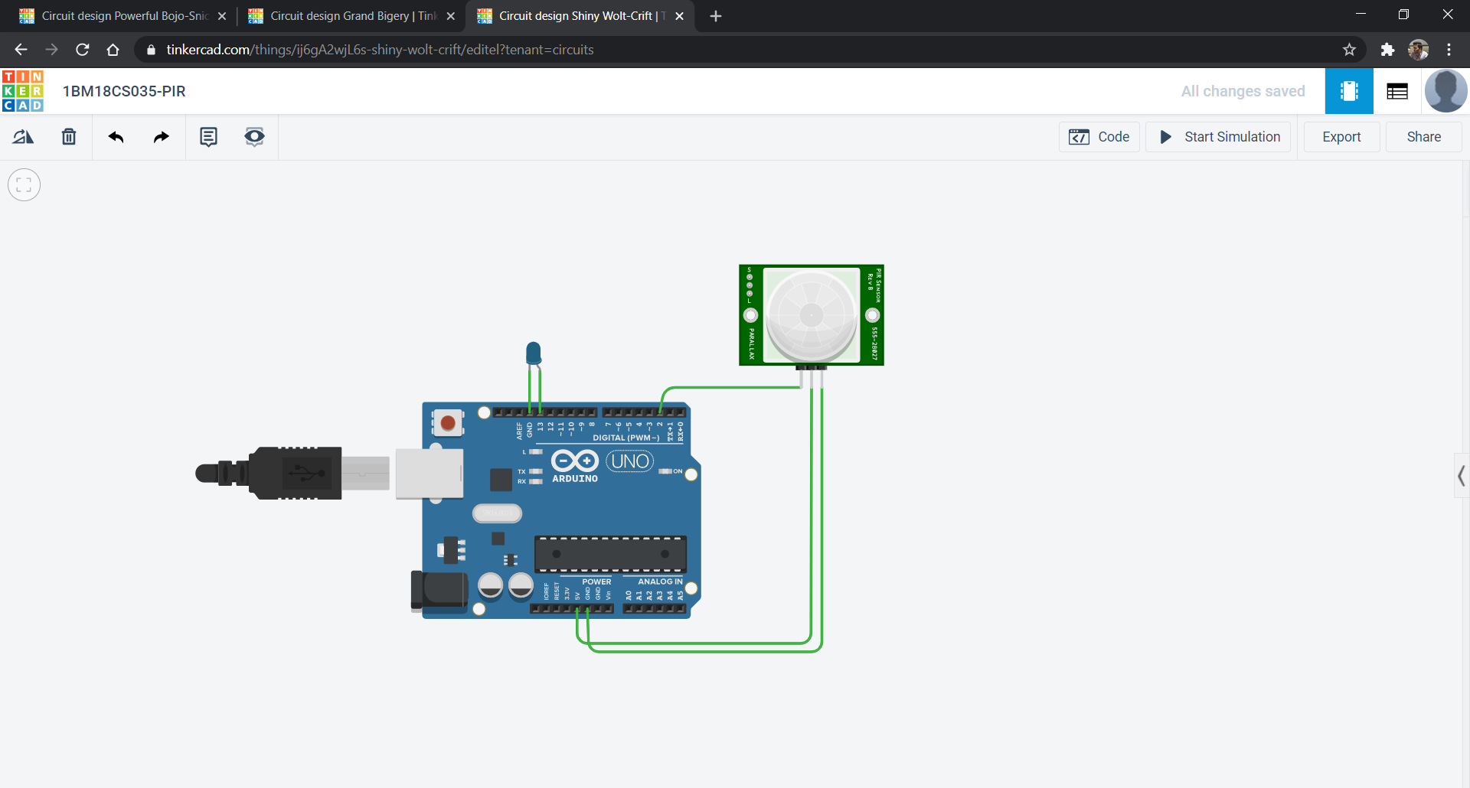

**Circuit diagram along with code:**

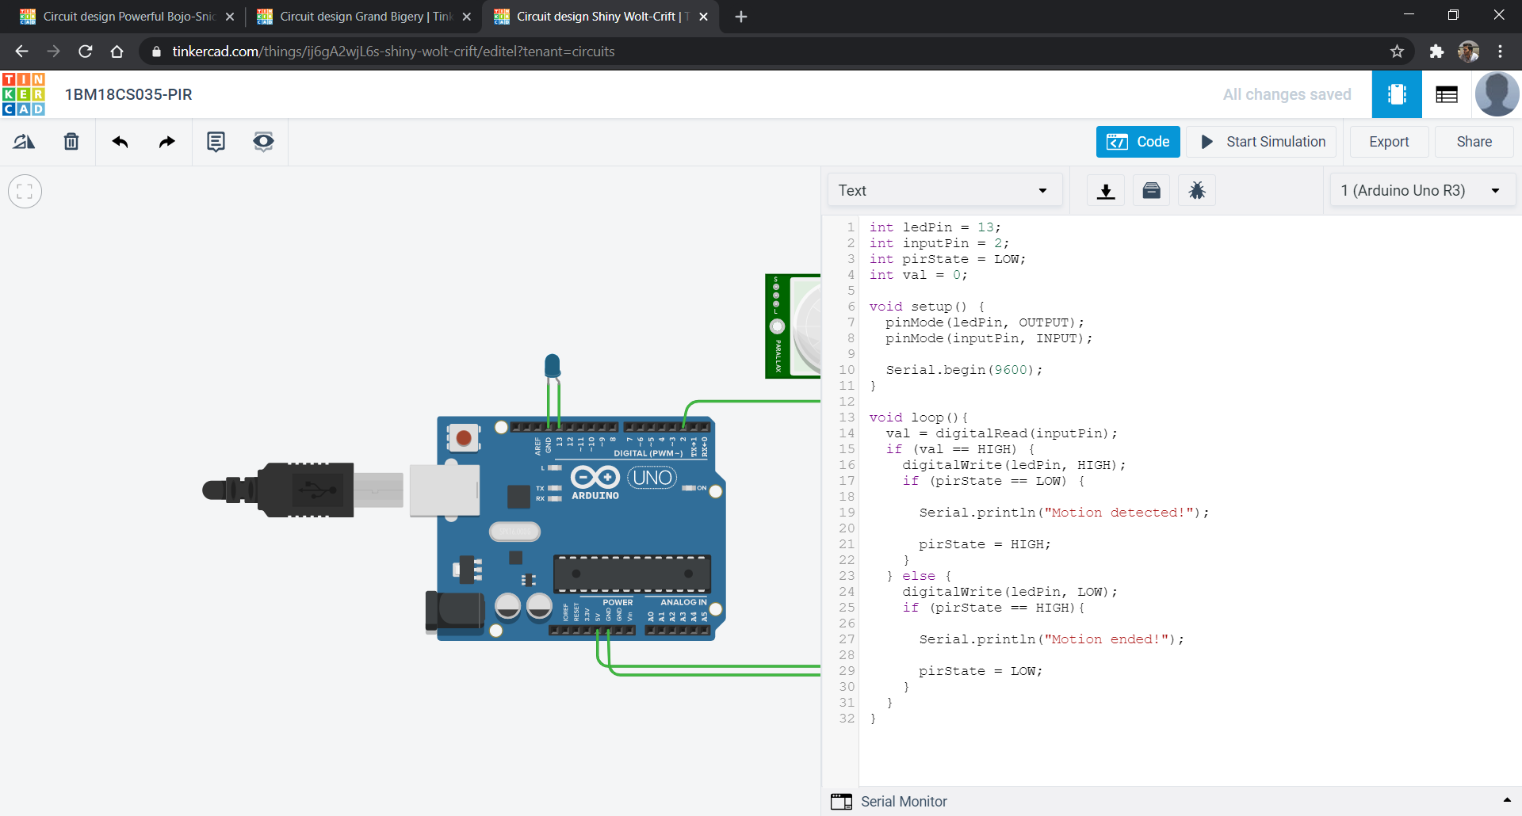

**Simulation:**

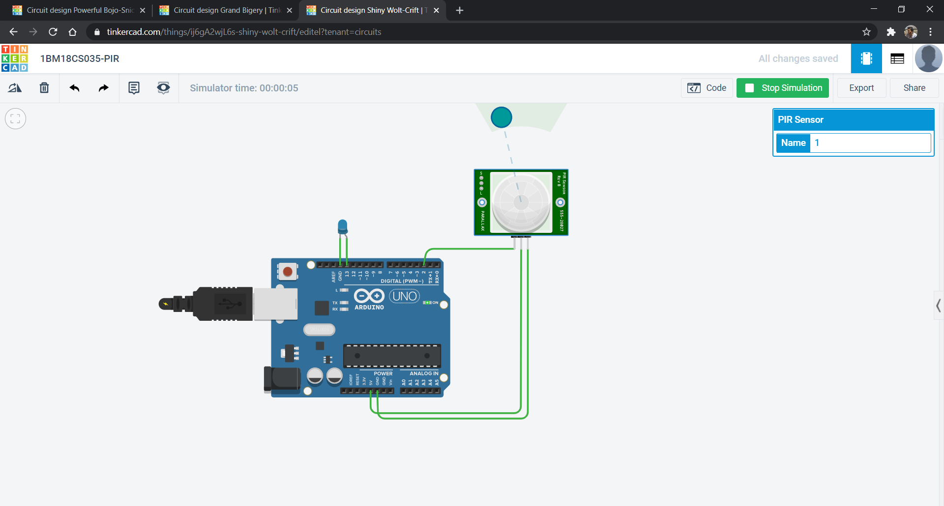

**Code:**

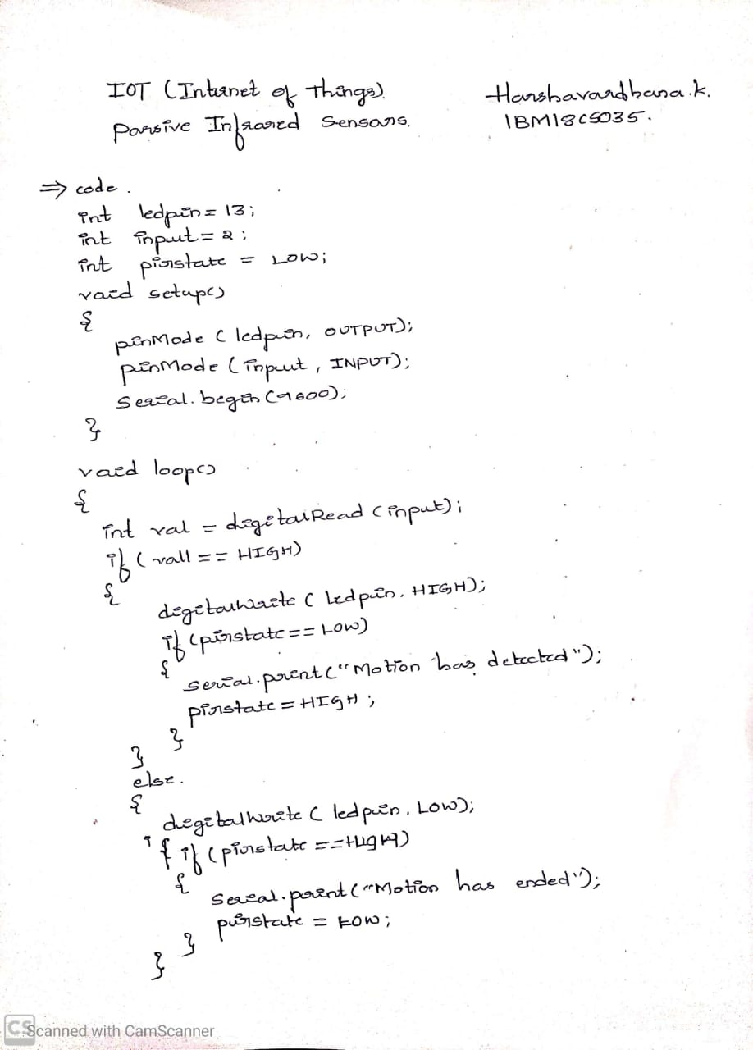

**Observation/output:**

Led was turned on whenever there is motion.